**PROJECT REPORT FOR VOYAGE VISTA: lllUMINATING INSINGHTS FROM UBER**

1. **INTRODUCTION**

1.1 **overview**

Uber technologies lnc., fpunded in 2009 by travis kalanick and garrentt camp, revolutionized the transportation industry with its innovative ride-sharing platform. By seamleesly connecting riders with drivers through a user –friendly mobile application, uber transformed traditional taxi services, offering a convenient, efficient, and often more affordable way to travel. Expanding globally in a short span of time, uber has also ventured into food delivery, freight transportation, and autonomous vehicle research, cementing its reputation as a leading technology disruptor.

* 1. **Purpose:**

Uber primary purpose is to provide a reliable and accessible means of transportation for everyone, everywhere. By leveraging technology, uber aims to make transporation safer, more efficient , and more convenient, reducing the need for personal car ownership and thereby decreasing congestion and pollution in cities. Additionally , uber seeks to provide economic opportunities for drivers and delivery persons, while also expanding its patform to encompass other services like food delivery .

2.**PROBLEM DEFINITION AND DESIGN THINKING**

2.1 **EMATHY MAP**

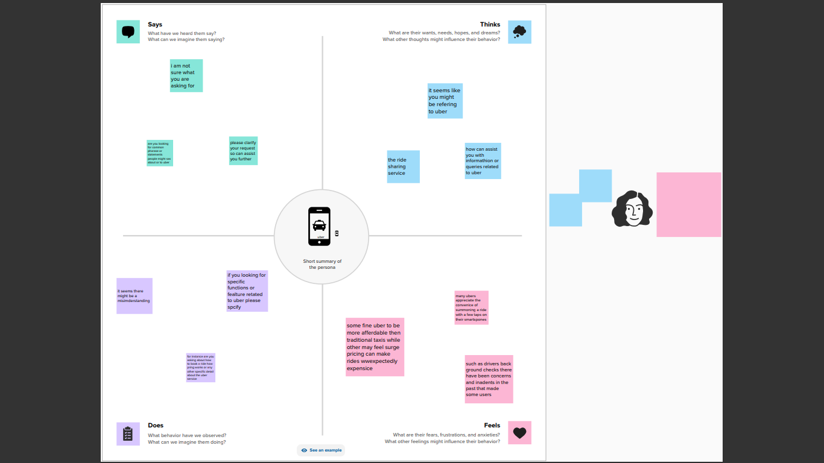

2.2 **IDEATION AND BRAINSTORMING MAP**

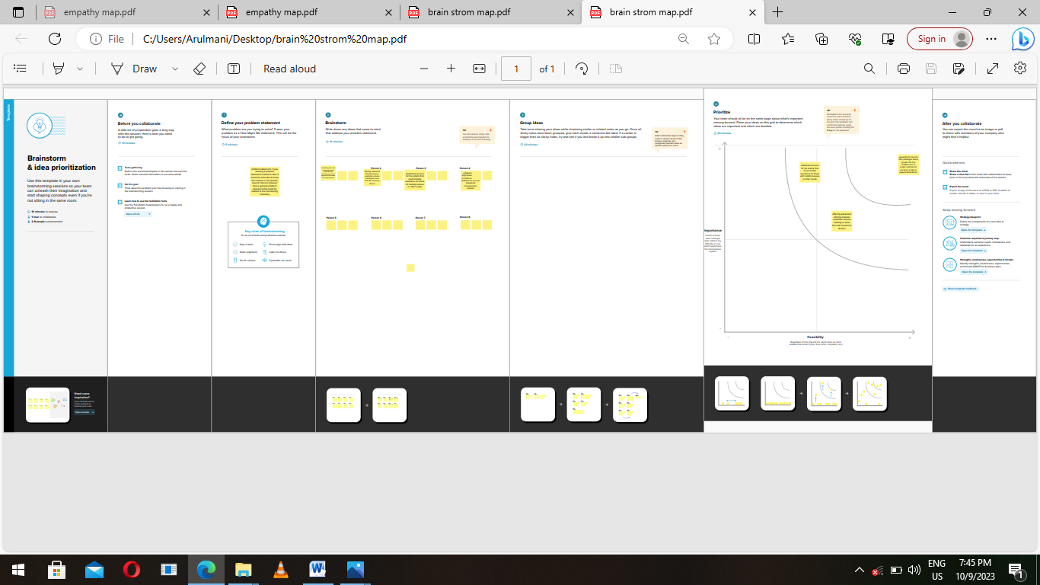

3.**RESULT**:

**UBER SUB BRANCHES** :

1.**UBER RIDES:**

uberX: basic serives for up to 4 rides.

UberXL: Larger vehicles for more passengers.

Uber POOL: shared ride with others going in the same direction.

2.**UBER EATS**: A food delivery serivece where users can order from local restaurants.

3.**UBER FREIGHT**: Connects shippers with truck drivers, similar to the ride-hailing app but for cargo.

4.**UBER HEALTH**: A service designed to provide reliable transporatation for patients.

5.**UBER BUSINESS**: Offers solutions for businesses to manage ground transportation for their employees.

These are some of the primary services uber has instroduced over the years. However, uber constantly innovates and experiments, so there might be new services or changes to existing services post-2021 . Always check the official up to date information.

**DASHBOARD AND**

1. 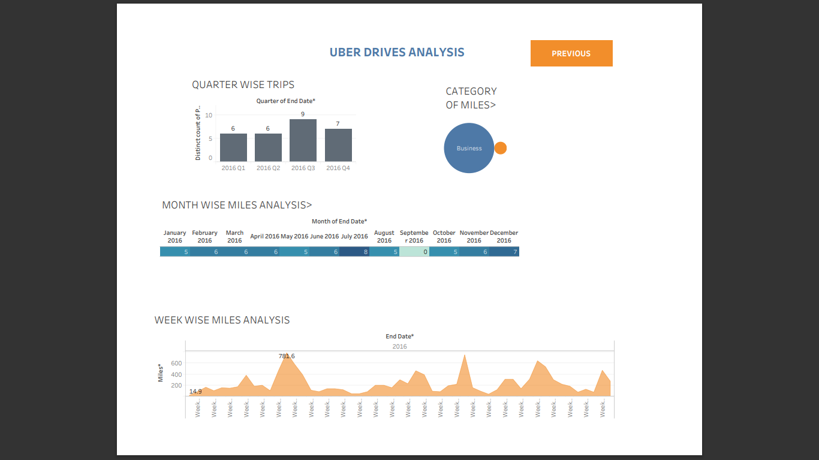sssss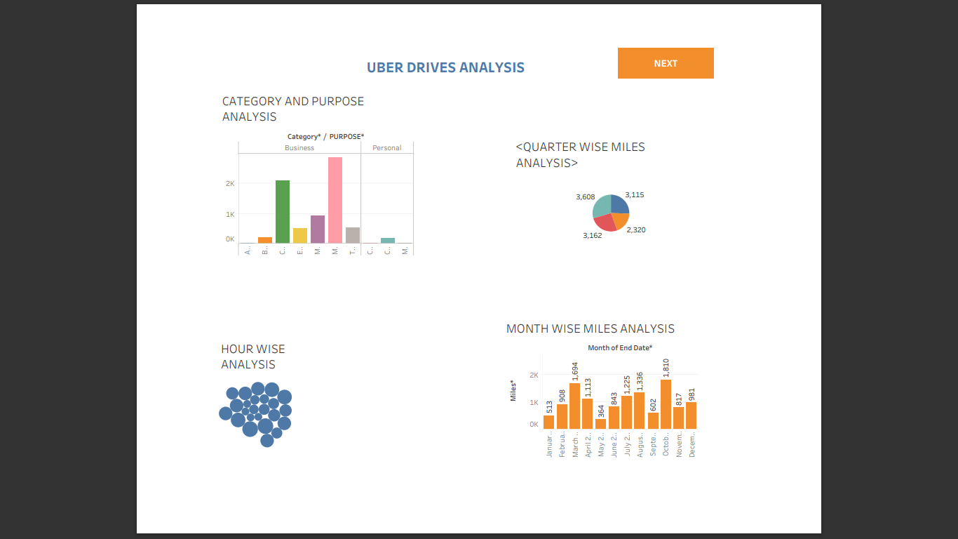

**STORY**

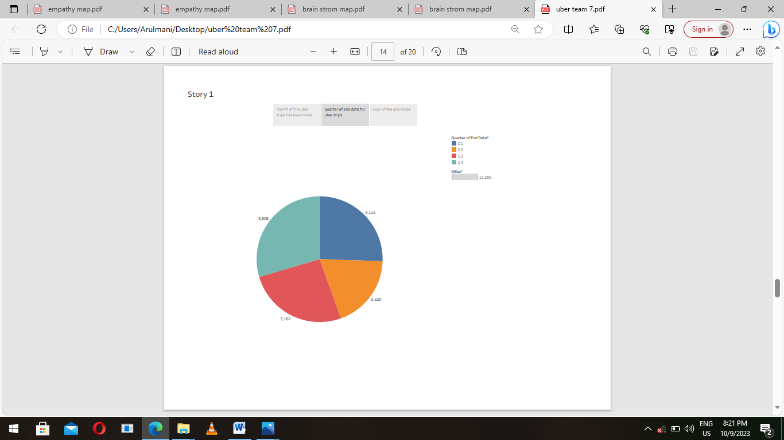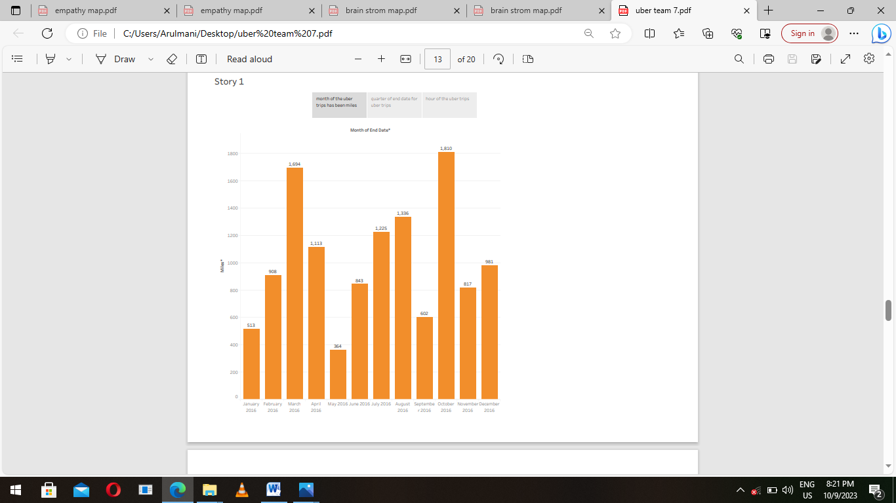



**STORY** 2. 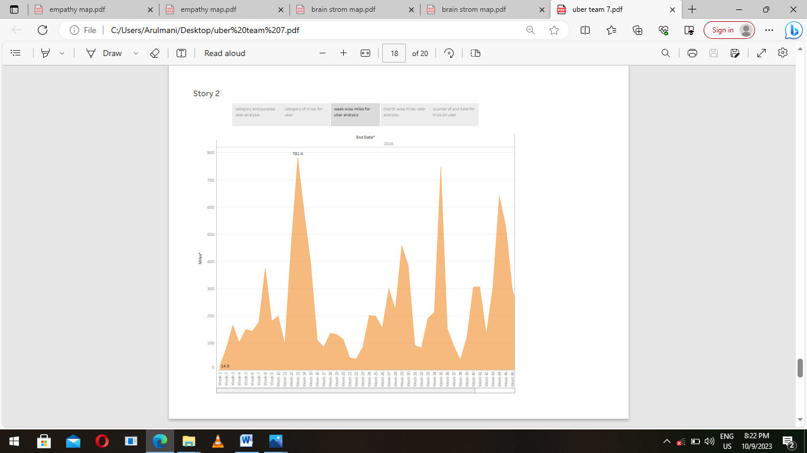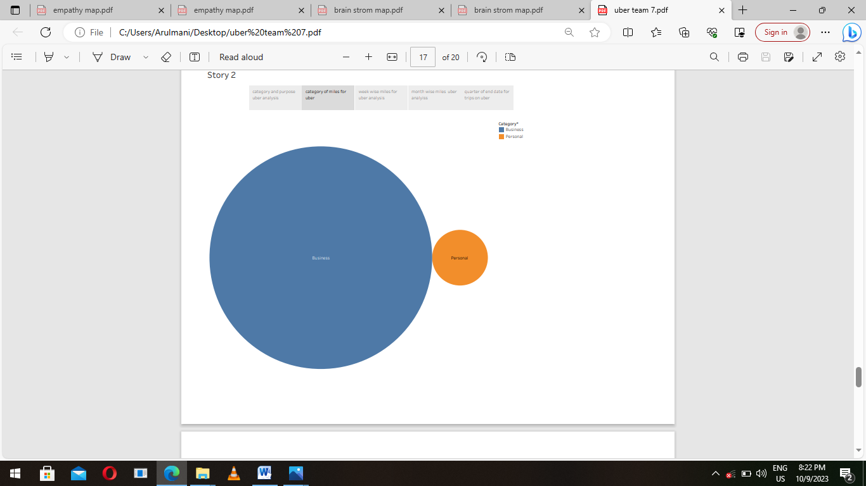

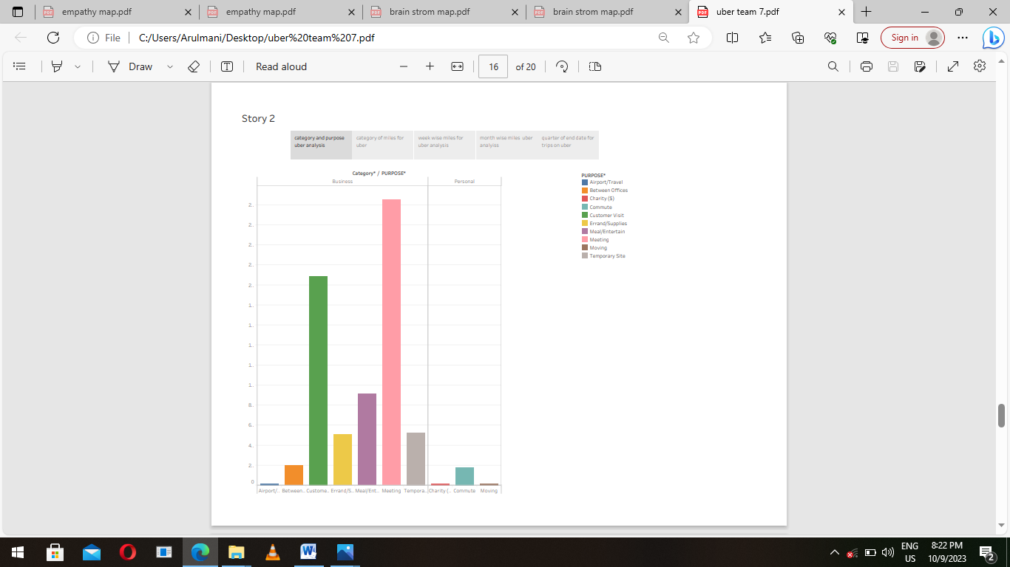

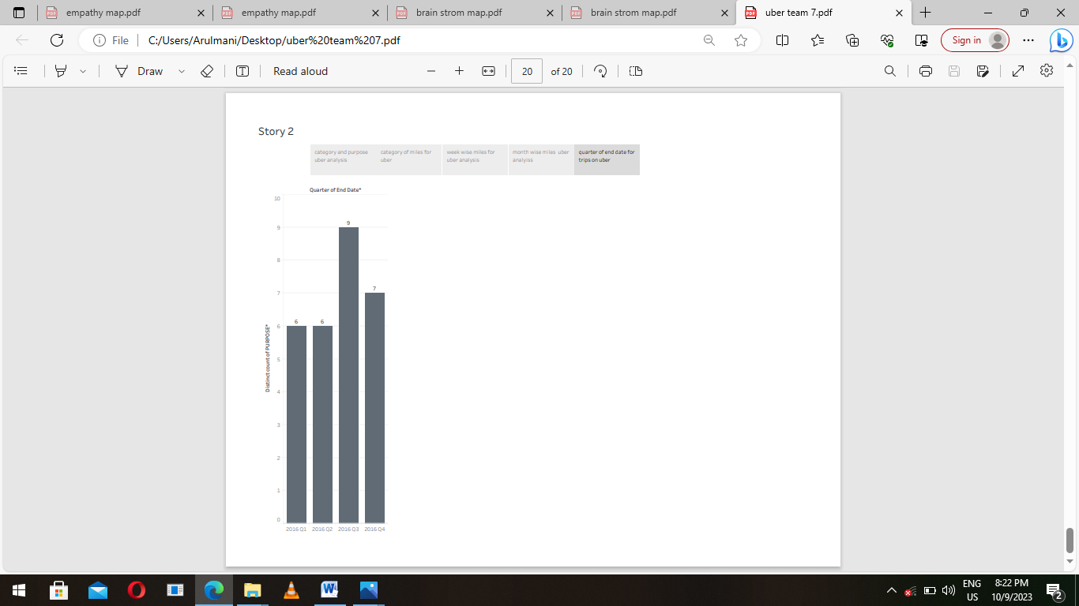

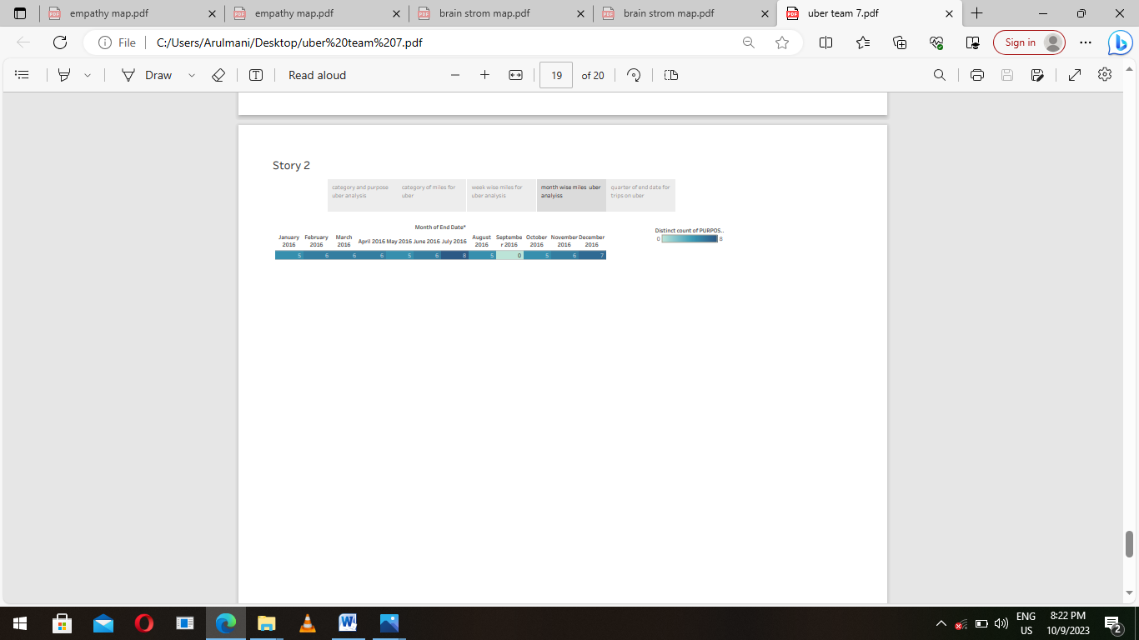

4. **ADVANTAGES AND DISADVANTAGES**

4.1 **ADVANTAGES FOR UBER**

1. **Convenience** : Users request a ride with a few taps on their smartphone without the need to hail a

Taxi on the street or make a phone call.

2.**Cashless Transactions**: The platform allows users to pay via credit card, debit card, or other mobile payment methods, eliminating the need for cash.

3.**Rating system**: Both drivers and passengers rate each other, aiming to ensure a pleasant experience for both parties.

4. **Price Transparency**: Before booking a ride, users get an estimate of how much it will cost. **Flexible Employment**: For drivers, uber offers a flexible work schedule. They can choose when and how often to work

6. **Safety Measures**: Features like GPS tracking, emergency buttons, and trip sharing with trusted contacts are intended to improve safety.

7. **Sure pricing**: While controversial, surge pricing can increase the availty of drivers during peak demand times.

8. **Variety of services**: Uber isnot just about car rides. They offer different of vehicles and even expanded to delivery serices like uber eats.

9.**Global Presence**: Uber operates in many countries and citiesaround the world making it convenient for travelers.

10.**Reduced Need for personal**: In urban areas some people find t more economical and convenient to reply on uber instead of owning a car.

11. **Innovation**: Uber frequently updates its app to include new features and services based on user feedback and technological advancements.

12. **Economic**: In cities where it operates, uber can provide a boost to the local economy by creating job opportunities and increasing mobiiiiility.

4.2: **DISADVANTANAGE FOR UBER**

1.**Surge pricing**: Users often find surge pricing to be expensive and unpredictable.

2. **Driver Exploitation concerns**: Critics argue that uber drivers arenot paid fairly given that they responsible for their own cars maintenaces fual and other expense.

3.**Safety concerns**: While ubers has safety features in places there have been reports of assaults accidents and other safety incidents involving uber rides.

4.**Job stability for drivers**: As independent contractors uber drivers lack certain benefits such as health insurance sick leave and unemployment benefits.

5.**Traffic congestion**: Some studies suggest that ride-sharing services like uber increase traffic congestion in urban areas.

6. **Competition with public Transit**: uber can divert ridership from public transit, which could have long-term implications on public transtation funding and viability.

7.**Regulatory challenges**: Ubwr has faced legel challenges in many cities and countries where local government and taxi unions have rasised concerns about its operations.

8.**Environmental impact**: The increase in the number of case searing for passengers amy lead to more greenhouse gas emissions.

9.**Lack of Loyalty**: Unlike traditional taxi services or car rentals that often loyalty programs, uber doesnot often a consistent loyalthy programs for frequest riders.

10.**Depersonalization:some** : Some users feel the transactional nature of the platform reduces human interaction and leads to a more impersonal travel experience.

5**.APPLICATIONS**:

a. **DOCUMENTATION**: Submit the required documents which might include:

* A vaild drivers license

* Proof of residency in your city or state

* Proof of vehicle insurance

* Aclear photo of your self

b**. V LE REQUIREMENTS**: Your car should meet uber standard which very by city but generally include.

* Vehicle age requirement older than 15 years but it varies by city

* Good condition with no cosmetic damage

* No commercial branding

c. **BACKGROUND CHECK**: After providing the necessary douments you undergo a background check. This process checks your driving recond and criminal history.

d**. START DRIVING**: Once all requirements are met you can start accepting rides.

6. **CONCLUSION**:

Uber has revolutionized the transpotation industry by leverging technology to provided a convenient and user-friendly ride-hailing service.While it offers numberous advantage such as ease of use cashless transactions and flexible employement oppertunitiess for driver it also faces criticisms relarted to surge pricing driver compensation and safety concerns. As with many disruptive innovations uber emergency has propted discussions about regulations,labor rights and the future of urban presence and adaptability highlight its significance but its crucial for the platform to address its challenges to ensure long- term success public trust.

7. **FUTURE SCOPE FOR UBER:**

1.**Autonomous Vehicles**: uber has invested in self driving technology while they sold their autonomous car unit to aurors in late 2020 they still have a stake in the automous vechicle sector, and partnership or integrations in the future could change urben mobility.

2.**Safety and tech innovations**: In light continually upprade its tech features including better background and emergency response integrations.

3. **Collaborations and pssrnerships**: Uber might partner with tech companies automotive manufactures and other industries for technological advabcement and services expansion.

4. **Health transportation**: Uber health a service that helps healthcare organzations and caregivers provided rides for patients might see furture growth especially gven the increasing focus on healthcare access and infrastructure.

5. **Subscrption models**:Uber might look into offering subscription models providing regular users with fixed rate pricing or other perks future integrating their services into users daily liviies.

6. **Financial services**: Uber has already ventured into financial services with uber money which includes a digital wallet and upgraded debit and credit catds. This could be expanded future.

7. **Expansion in emerging markets**: There are still many markets particularly in Africa and parts of asaia where uber can grow. Localized services tailored to there regions could be on the horizon.

8**.Green mobility**: As the push for sustainability grows uber might invest more in electric vehicles partnerships with EV charging stations vehicle adoption among its drivers.